Data Co Supply chain & E-commerce
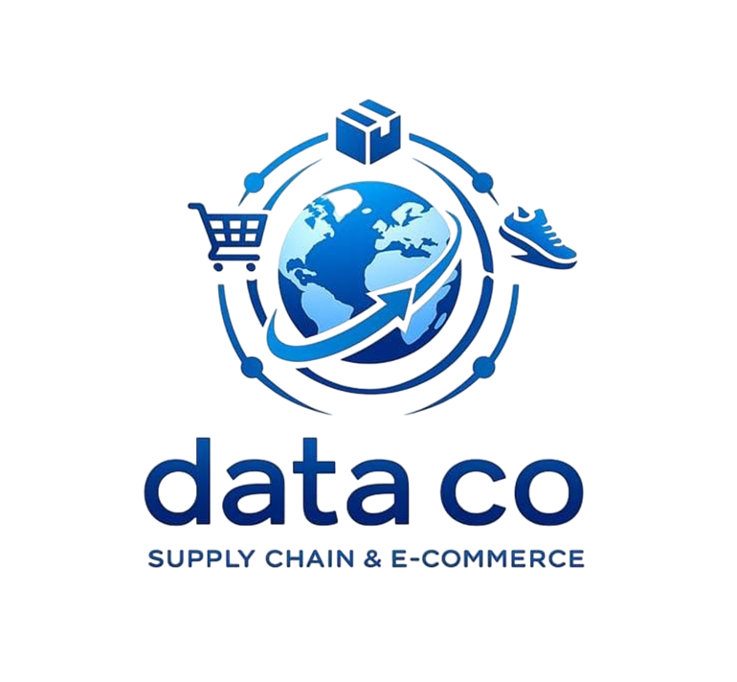
Our Team

1- Zyad Reda Fouda
•Graduated from GSU joint program with Cairo university 2025.
•Finance & Investments Major.

2- Hagar Ali Hendam
•Student at faclty of Engineering.
•Electronics and electrical communications Major.

3- Norhan Rabea Hassan
•Graduated from Computer Science Al Fayoum university 2025.
•Computer & Artificial Intelligence Major.

1- Data Description

DataCo is a global e-commerce company that operates an online merchandise store, shipping products to customers worldwide from a central hub located in Asia. The primary objective of this project is to analyze the dataset to generate meaning insights that can help enhance the business operations of DataCo. By interpreting key trends, patterns, and performance metrics, the analysis will aim to offer actionable recommendations for optimizing efficiency and decision-making across the supply chain.

2- Cleaning & Normalization Stage

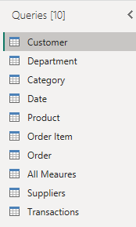

- Customer Table:

- Merged Fname and Lname in a new column Named by Customer Full Name.
- Remove the Fname and Lname column.
- In the Customer ID column we removed duplicates because Two customers cannot share the same number in ID.
- Change ( EE. UU ) in the Customer City column to ( United States ).
- EE. UU refers to Estados Unidos (United States) in Spanish as EE. UU.

- Products Table:

- I made sure and checked that all the numbers are correct.

e) Orders Table:
- Remove duplicates from Order Id, Order Customer Id,Order City, Order State, Order Country columns
- Change type of order date (DateOrders) from Data/Time to Date only, then remove duplicates
- Select Order Status column ,formate⇒capitalize each word, then replace underscore with space of Pending_Payment & Payment_Review

f) Date Table:
- Change type of order date (DateOrders) from Data/Time to Date only, then remove duplicates
- Extract (year, month, month name, quarter, day of week and day name) .

g) Product Table:
- We remove duplicates the columns of product id.

H) Order Item Id Table.

I) Suppliers Table.

J) Transactions Table:
- We remove duplicates of the columns of product id.

3- Setting Measures Stage

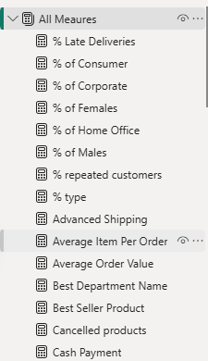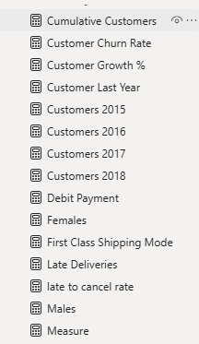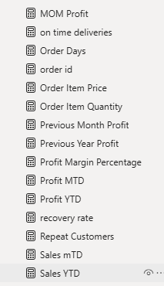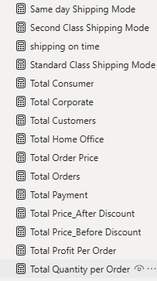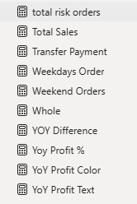

4- Data Visualization Stage

- We used in data visualization so many different charts that can show the information in different ways like: ( pie chart, bar chart, tables and matrix tables, cards, maps, stacked bar chart, clustered column chart and etc….) to make it easy as possible to be understandable and clear to others.
- 6- Model View

- 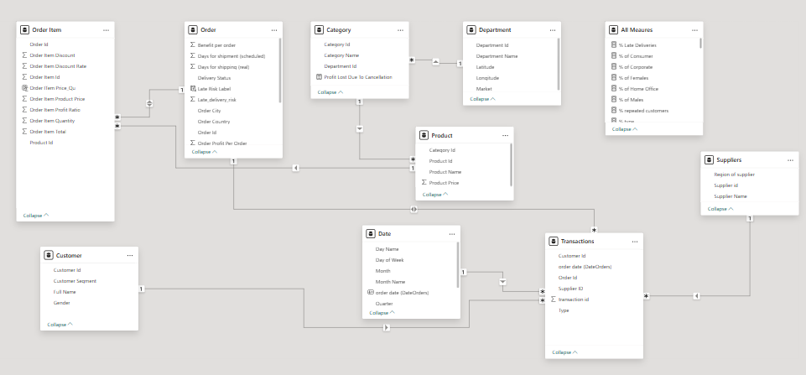

5- Dashboard

- After we setting mesures ,we used it to make our visuals

